2.0 SYSTEM ANALYSIS

2.1 REQUIREMENT OF NEW SYSTEM

EXISTING SYSTEM

- In the existing system all transactions, dealings of products, purchasing of products were done manually which is time consuming.
- In the existing system only one category and a few products which is very limited.
- Reports are prepared manually as and when needed. Maintaining of reports is very tedious task.
- To buy any product user has to collect information about it either by visiting the shop or asking people which is the better one.
- There is no computer system for handling payments. All calculations are performed manually which may not be accurate always. Maintaining the record is really a tedious task.

NEED FOR NEW SYSTEM

- Need for the new system is due to major drawbacks of existing system.
- Reports can be generated at any time within few seconds, so that manual lab our is not required, and also analysis can be performed much more frequently which helps in taking decision.
- The details regarding all users, products can also be maintained as their information is very helpful and sometimes becomes a critical requirement.
- Allows user to get registered from their places and transact for the required product.

2.2 FEATURES OF NEW SYSTEM
There are many useful Features in our system some of them are listed below:

- Our website is secure as it automatically gets logout on clicking Checkout button & Session will be clear.
- All forms are secured by login page, so visitor cannot perform any operation which may cause updating in database.

2.3 PLANNING FOR NEW SYSTEM

- To solve actual problems in an industry setting, a software engineer or a team of engineers must incorporate a development strategy that encompass the process, methods, and tools layers and generic phases. This strategy is often referred to as process model or a software engineering paradigm. A process model for software engineering is chosen based on the nature of the project and application, the methods and tools to be used, and the controls and deliverables that are required
- Types of Software Process Models:
- The Prototyping Model
- The Rapid Application Development(RAD)Model
- The Incremental Model
- The spiral Model
- The Win Win spiral Model
- The concurrent Development model

2.3.1Process Model for current project:-

Incremental Model:-

This software is based on Incremental software process model. The Incremental Model combines elements of the linear sequential model with the iterative philosophy of prototyping. The incremental model applies linear sequences in a staged fashion as calendar time progresses.

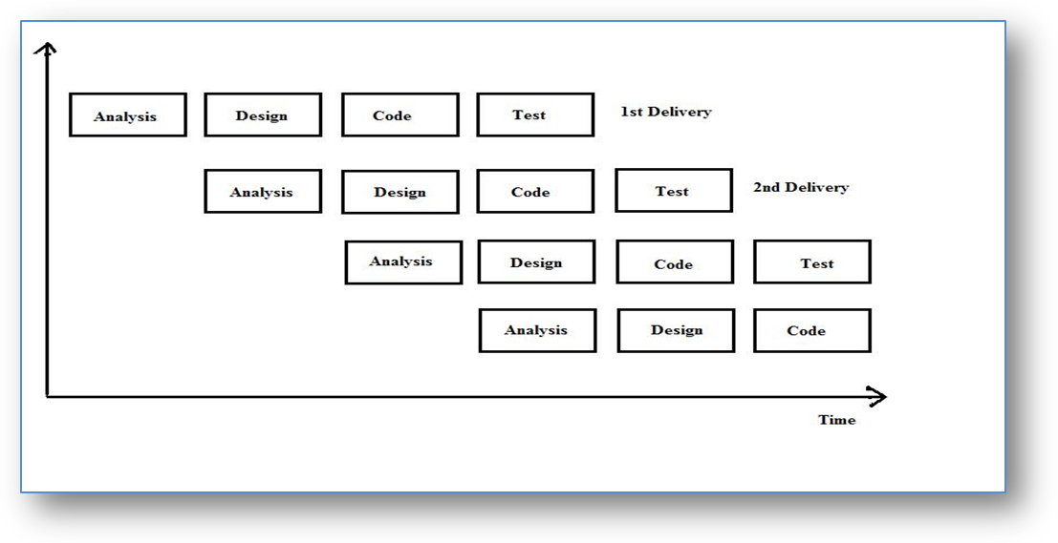
Each linear sequence produces a deliverable “increment” of the software. It should be noted that the process flow for any increment could incorporate the prototyping paradigm. When an incremental model is used, the first increment is often a core product.
That is, basic requirements are addressed, but many supplementary features remain undelivered. The core product is used by the customer. As a result of use and/or evaluation, a plan is developed for next increment. The plan addresses the modification of the core product to better meet the needs of the customer and the delivery of additional features and functionalities. This process is repeated following the delivery of each increment, until the complete product is produced. The Incremental process model, like prototyping and other evolution approaches, is iterative in nature.
The reason for choosing it as process model for this project is that, since all the requirements are available at initial stage we can rely on this model for further step by step implementations and also the project includes leveling. Therefore, after the complete implementations of 1st level, we can go for the next easily using this model.

2.3.2 Project Planning:

The project must strictly follow the Software Development Lifecycle.

Planning – establishing the plans for creating a system by defining the system to be developed – based on the systems prioritized according to the organization, a system must be identified and chosen. The project scope – a high level of system requirements must be defined and put into a project scope document. Developing the project plan – all details from tasks to be completed, who completed them and when they were completed must be formalized. Managing and monitoring the project plan – this allows the organization to stay on track, creating project milestones which allow you to add to the initial plan.

Analysis – the users and IT specialists collaborate to collect, comprehend, and logistically formalize business requirements by Gathering the business requirements' – IT specialists and knowledge workers collaborate and discuss which tasks to undertake to make the system most successful. Analyzing the requirements – business requirements are prioritized and put in a requirements definition document where the knowledge worker will approve and place their signatures.

    - Project Scheduling:

  - “Software project scheduling is an activity that distributes estimated efforts across the planned duration by allocating the effort to specific software engineering tasks.”
  - Proper Scheduling required: All tasks appear in network. Effort and timing are intelligently allocated to each task. Interdependencies between tasks are properly indicated. Resources are allocated for the work to be done.

Though there are many reasons for completion of project, following are the prominent ones that are the roots of late completion.

- Unrealistic deadline estimation under estimation under excitation of getting a project or under some other pressure.
- Changing user requirements that are not reflected in schedule changes.
- Underestimate of the amount of efforts and the number of resources that will be required to perform the task.
- Conceptual change requirement during the course of the project.
- An inappropriate distribution of time.
- Human/Natural problems that were not predicted.
- Failure in recognizing that project is lagging behind schedule.

2.3.4 Risk Managrment:-
It presents a holistic vision of the risk-based methodologies for Software Risk Management (SRM) developed at the Software Engineering Institute (SEI). SRM methodologies address the entire life cycle of software acquisition, development, and maintenance. The premise that the ultimate efficacy of the developed methodologies and tools for software engineering is to buy smarter, manage more effectively, identify opportunities for continuous improvement, use available information and databases more efficiently, improve industry, raise the community’s playing field, and review and evaluate progress.
The methodologies are based on seven management principles: shared product vision, teamwork, global perspective, forward-looking view, open communication, integrated management, and continuous process.
The need to manage risk increases with system complexity. As the complexity of the system increases, both technical and non-technical (cost and schedule) risks increase. There is an increasing need for more systematic methods and tools to supplement individual knowledge, judgment, and experience. These human traits are often sufficient to address less complex risks. It is worth noting that many managers believe that they are managing risk in its multifaceted dimensions.

Risk Analysis:
Risk analysis is the process of defining and analyzing the dangers to individuals, businesses and government agencies posed by potential natural and human-caused adverse events. A risk analysis report can be either quantitative or qualitative. In quantitative risk analysis, an attempt is made to numerically determine the probabilities of various adverse events and the likely extent of the losses if a particular event takes place.
Qualitative risk analysis, which is used more often, does not involve numerical probabilities or predictions of loss. Instead, the qualitative method involves defining the various threats, determining the extent of vulnerabilities and devising countermeasures should an attack occur.
Risk Identification:-
Risk Identification is a systematic attempt to specify threats to the project plan (estimates, schedule, resource loading, etc.). By identifying known and predictable risks, the project manager takes a first step toward avoiding them when possible and controlling them when necessary.
One method of identifying risk is to create a risk item checklist. The checklist can be used for risk identification and focuses on some subset of known and predictable risks in the following generic subcategories:

Performance Risk:
The degree of uncertainty that the product will meet its requirements and be fit for its intended use. As far as our project is concerned, we have given unambiguous requirement of project so that risk is very less.

Cost Risk:
The degree of uncertainty that the project budget will be maintained. It is very less because of sufficient financial resources.

Support Risk: -
The degree of uncertainty that the resultant software will be easy to correct, adapt, and enhance. Because of user friendly GUI it’s easy to correct, adapt or enhance the project in future.

Schedule risk: -
The degree of uncertainty that the project schedule will be maintained and that the product will be delivered on time. It was very less in this case because of effective management and scheduling of our project guide and his support to schedule work evenly.
During the project plan we have consider all the proactive which we have think we will face during the project period. Here we have listed the risks which we have considered during the project plan:
  - Possibility that if the one mistake during data dictionary is reflecting all other modules data dictionary so it is complicated to change it.
  - Possibility that entry for account is incorrect so it is reflecting in balanced of the final calculation.
  - Possibility that the hardware resources are not available during the project period.
  - Possibility that Server going down for log time so it is slow down whole transaction of the firm’s money & other related issues in accounting module, to which we have to make the connection might not available.

  - FEASIBILITY STUDY
A feasibility study is an evaluation of a proposal designed to determine the difficulty in carrying out a designated task. Generally, a feasibility study precedes technical development and project implementation. In other words, a feasibility study is an evaluation or analysis of the potential impact of a proposed project.

Opeational Feasibility
Is a measure of how well a proposed system solves the problems, and takes advantages of the opportunities identified during scope definition and how it satisfies the requirements identified in the requirements analysis phase of system development.
Web ERP is a complete web based accounting/ERP system that requires only a web-browser and pdf reader to use. It has a wide range of features suitable for many businesses particularly distributed businesses in wholesale and distribution. It is developed as an open-source application. The feature set is continually expanding as new businesses and developers adopt it.
But here these WebERP is developed in java platform and working only in Our Organisation Environment.But if we want to convert in web based then also it is working because at the end it is web application bases.

Technical Feasibility
Technological feasibility is carried out to determine whether the company has the capability, in terms of software, hardware, personnel and expertise, to handle the completion of the project.
Now in term of Technical Feasibility Our Organization is on Government Bases,So there is no worry about capability because government is supporting us very well.
Our organization is well established and it is also conduct one traning schedule ones in a year so it have take advantages from tranee’s work and supporting them in their project work and also an Oraganisation have Software Department studio in which all the employee of our organisation are going to maitain our software and also developed S/W application based on the requirenment of the government organisation.
So, from the above information there is no worry in terms of manpower, software and hardware requirenment. Considering all above points and expects it is observed that the cost that would be incurred in developing this project from a technical perspective would not be too high. The client has agreed to the same. Thus it is feasible to the company.
Financial & Economical Feasibility
Economic analysis is the most frequently used method for evaluating the effectiveness of a new system. More commonly known as cost/benefit analysis, the procedure is to determine the benefits and savings that are expected from a candidate system and compare them with costs. If benefits outweigh costs, then the decision is made to design and implement the system. An entrepreneur must accurately weigh the cost versus benefits before taking an action.

Schedule Feasibility
A project will fail if it takes too long to be completed before it is useful. Typically this means estimating how long the system will take to develop, and if it can be completed in a given time period using some methods like payback period.
Schedule feasibility is a measure of how reasonable the project timetable is. Given our technical expertise, are the project deadlines reasonable? Some projects are initiated with specific deadlines. You need to determine whether the deadlines are mandatory or desirable. time is one of the critical factor in the development of any system but this kind of feasibility is hardly perfect in any system.
Our organization has to decide recently in 2010 that they are going for ERP. For These ERP development, Analyses part is given to the trainee people and coding and implementation of these system is given to the employee.
As we know that these kind of project take long period of implementation time so as a trainee our work is given to them a complete analyses part up to coding phase & give all kind of help in their coding and deploying section.

Implementation Feasibility
- Under the study of implementation feasibility ,we have go to draw the finger to the certain issues like:
- Is it possible to install the software with the giving environment?

- Will organization management and user support for the installation of the software?

- Will proposed system cause any harm to the operations of the organization?

- Opera nationally, this system after installation it defiantly works according to its functionality.
- There would be very little barriers in implementation because it takes more than five months, but the management has already approved the software to be developed and it would in fact help in user’s operation or day-to-day activity.

